<Lai Zhang>

Northeastern university  360 Huntington Ave, Boston, MA.

Assignment 2 – Program Structure & Algorithms (is6205)

Contents

a. Questions 2

# Questions

1. **Test result and theoretical hypothesis.**

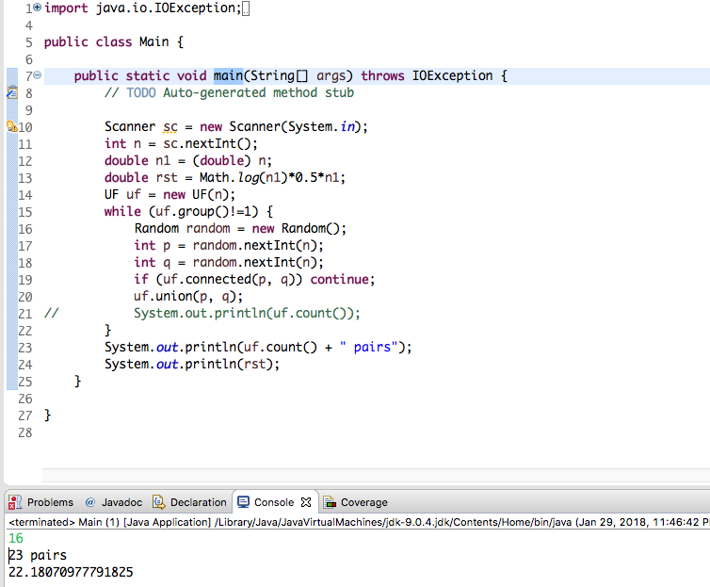

The hypothesis result should be ½*n*logn. With my input being 16(n=16), the theoretical result should be 22.1807, where the result is the time it takes to get all nodes connected. The result I got from the algorithm was 23 pair as has been shown in the screenshot above.

1. **The screenshot of Unittest**

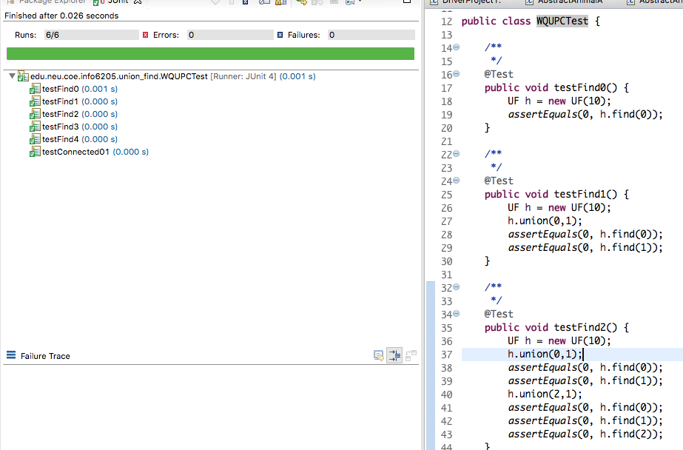

.

1. **Screenshot of Main method and UF class**

